Women in Colonial America
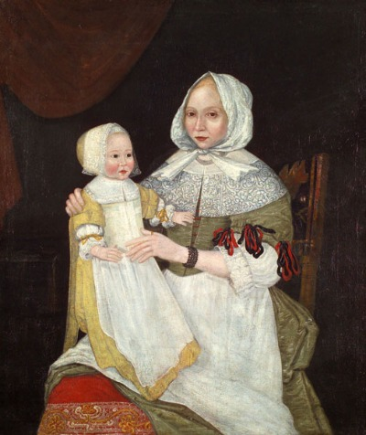Mrs. Elizabeth Clarke Freake and Baby Mary (c. 1672) opens in new window
The lives and experiences of women in colonial America was hardly monolithic. Here we will attempt to explore the histories of women in the colonies from a variety of perspectives.
The development of women's history in the 1960s and 1970s has uncovered a lot of history that was previously glossed over in national and political histories of the United States. Today, we know much more about the roles women played in colonial society, but there is still a lot that cannot be comprehensively studied. Women who could read and write kept diaries or wrote letters, some of which survived, but illiterate women from poorer and servile groups left no primary source records at all. Much of what we know about them comes from other people's writings or impersonal statistical data. What issues of source reliability might this generate? Does a wealthy literate woman writing about her female servants and slaves truly or fully capture their experiences?
Nevertheless, the diaries, journals, memoirs, and autobiographies we have from this period are important, regardless of who wrote them, as historian Laurel Thatcher Ulrich reminds us in her biography of midwife Martha Ballard from Maine (part of northern Massachusetts at the time): "Without [Ballard's] diary her biography would be little more than a succession of dates. Her birth in 1735. Her marriage to Ephraim Ballard in 1754. The births of their nine children in 1756, 1758, 1761, 1763, 1765, 1767, 1769, 1772, and 1779, and the deaths of three of them in 1769. Her own death in 1812." Her obituary summed up her life in a single sentence: "Died in Augusta, Mrs. Martha, consort of Mr. Ephraim Ballard, aged 77 years." Ulrich concludes, "Without the diary we would know nothing of her life after the last of her children was born, nothing of the 816 deliveries she performed between 1785 and 1812. We would not even be certain she had been a midwife."
The issues of source reliability and perspective is something you'll explore in your Module 2 Online Assignment.

Free Women
Families and the patriarchal authority of the husband and father defined colonial life for women. The vast majority of free women were the wives or daughters of yeoman farmers who directed their labor and lives. Their labor, as menial and monotonous as it seems to today, was essential. The survival and economic independence of the yeoman family hinged upon the tasks performed by wives and children. Most yeoman families could not afford indentured servants or slaves, so farm wives either worked unaided or with the help of their younger children and older daughters. The average free woman in colonial America married young, gave birth seven times or more, and spent most of her lifetime raising children. While sons began performing fieldwork around the age of three, daughters remained mostly in the home shadowing their mother and learning the domestic skills that would define their adulthood responsibilities as wives, mothers, and housekeepers (which for some began as early as the age of thirteen).
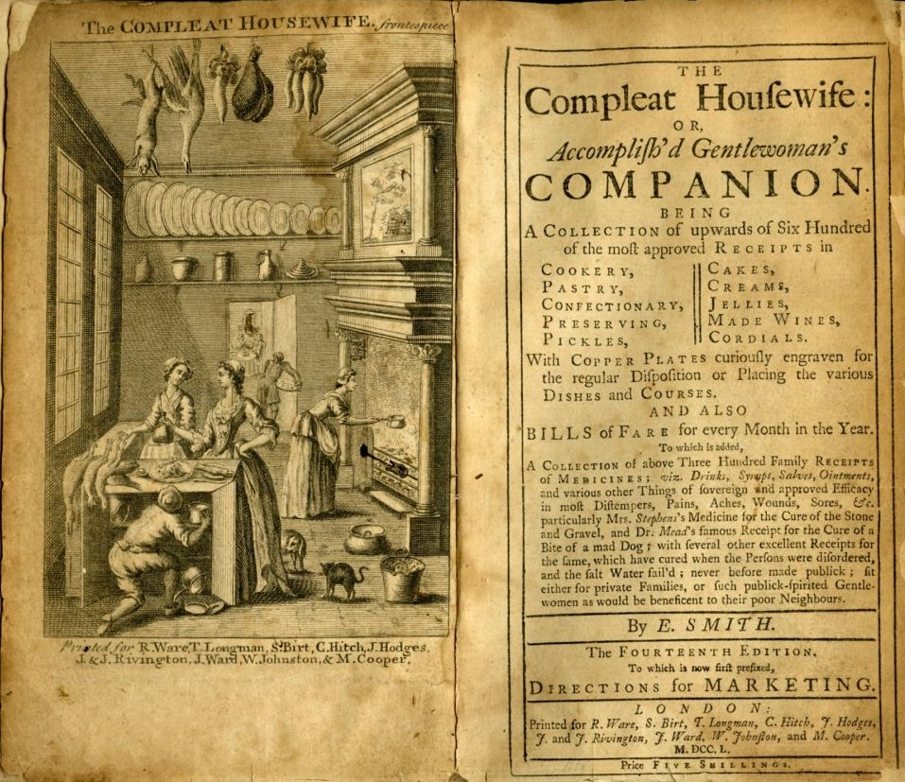Eliza Smith's The Compleat Housewife, or, Accomplish'd Gentlewoman's Companion opens in new window (originally printed in London in 1727) became the first cookery published in the Thirteen Colonies when it was reproduced at Williamsburg, Virginia, in 1742. It contains the first printed recipe for ketchup. Not only did it contain recipes for food, but offered literate married women helpful advice on running a household, like making homemade wine and preparing homemade medicines and salves.
Historian David Hackett Fischer discovered that in New England the age at first marriage was a lot higher than in other colonies. Men tended to marry at the age of 26 and women at 23 in the first century of colonization, but almost everyone in the colonies eventually did "tie the knot." He remarks, "This pattern which seems natural to us today was very different from western Europe in the mid-seventeenth century ... [where] many young men and women were never able to marry at any age. As many as 27 percent of England's adult population reached maturity without marrying." Marriage was expected of women in New England, as we'll see in a minute, for economic and legal protections. Women who reached the age of 30 without marrying were called "thornbacks" and Puritans suspected that failure to find a husband was a sign of God's ill favor.
The term domesticity is often used to describe the role women served in the home. Farm wives were highly skilled laborers as reflected in the seemingly innumerable and never-ending list of tasks they performed: canning, smoking, salting, preserving, and cooking food; baking bread; sheering sheep, cleaning and carding wool, spinning yarn, dyeing, weaving fabric, sewing and tailoring, and other textile work (most families owned their own spinning wheels and looms); butchering livestock; collecting feathers from butchered poultry to stuff home-sewn pillows and mattresses; sweeping, mopping, and dusting; milking cows, churning butter, making cheese; keeping bees and collecting honey; distilling homemade wines, cordials, beers, and spirits (very few people drank water, believing it to be unhealthy); making soap; making candles; teaching their children to read, write, and "cipher" (i.e., do arithmetic); performing family religious devotion in the absence of the husband; making medicines and salves; working in the fields with their husbands; nursing children. This list, of course, is not exhaustive. Many of these tasks were performed daily, while others were only performed at certain times of the year. Textile work was the most valuable of these skills, as surplus thread, yard, and fabric could be sold or bartered to supplement household income.
Women from wealthy households who had the luxury of servants still had to possess deep knowledge of these skills, as they were responsible for supervising and directing the household servants.
The places women spent time outside their homes was church and the homes of neighboring women (who were usually relatives or in-laws). Women were believed to be the spiritual equals to men, and could become full members of churches, but could not be ordained ministers or deacons, vote in church business, or even speak in church (the main exception to this was the Quakers). Most church meetinghouses were segregated by sex as well during services. The Bible informed Christian women of their role in the household and their duty to their husbands. Wives were expected to be submissive and obedient to their husbands, and their husbands were expected to be caring, loving, and protective of their wives. Women could not teach men in matters of religion, or assume any authority over men, but they could instruct other women. Bible studies were popular activities for women in New England towns. Groups of women met in a home and read and discussed the Bible and the Sunday sermon they had heard.
There were very few economic opportunities available to women in colonial America (or Europe) outside of marriage. Respectable female professions included midwifery (a midwife was a woman trained to help women deliver their children, something physicians did not specialize in), textile work (seamstress, tailor, dressmaker), and shop keeping; less respectable professions included servant work and tavern keeping; prostitution was present all over colonial America, and was universally condemned as disreputable, but for some young women who could not find a husband, did not have a familial support network, or any become employed in any other profession this might have been their only means for survival.
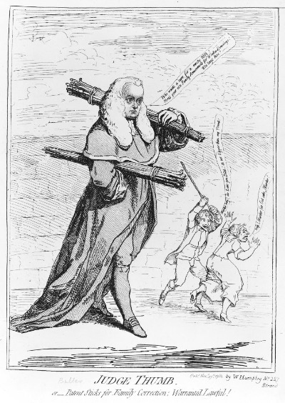"Judge Thumb"
Marriage was important for women in colonial America (and Europe) not only for economic protection, but legal protection as well. Women had very few rights in colonial society or in England, especially married women. A married woman could not own property (but did have "dower rights" to one-third of her husband's property if he died before she did). Married women could not sign contracts, swear oaths, sue, or be sued. This made it difficult if not impossible for a married woman to own or conduct business without her husband. The law allowed husbands to discipline their wives. In 1782, a judge in England was criticized when he ruled that husbands could beat their wives with implements no wider than their thumb (this was a already a common practice in England and America called the "rule of thumb" that the judge codified into common law) as long as they didn't draw blood. This made divorce on account of abuse nearly impossible.
In almost every respect, the law viewed married woman as it did children, as dependents, therefore if a divorce was ever granted a mother was almost never given custody over her children. A young widowed woman's children could be legally taken from her by the state and placed in other households as indentured servants if she didn't remarry.
The English and French operated under a system called coverture, where a married woman (femme covert) and her rights were "covered" by her husband. He was responsible for protecting and representing her interests in courts of law if necessary. When the women's rights movement mobilized in the mid nineteenth century, the laws of coverture were the first to be targeted by reformers.
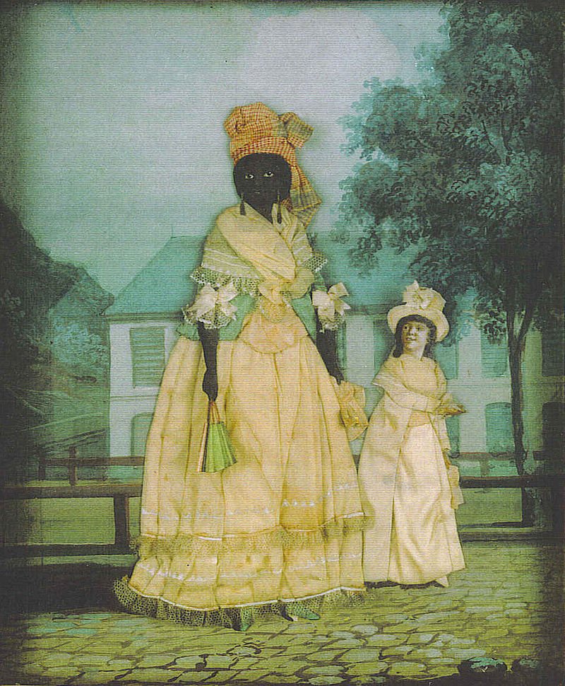Painting by an unknown artist of an unknown free black woman and her quadroon opens in new window daughter in eigteenth-century French New Orleans. Most free black women in French colonial society lived under similar conditions as their counterparts in British America, but the larger towns and cities like New Orleans offered greater economic opportunities for black women (as seamstresses, shop keepers, tavern keepers, and prostitutes). The racial hierarchy in French colonial society was much more elaborate than in British America, where people were legally recognized as either white, black, or Indian.
Unmarried women (including widows) could own property, sign contracts, sue and be sued, and therefore conduct business. Single women still suffered legal disadvantages since the law did not always recognize an independent woman's independence, or saw it as a threat to the moral fabric of society (remember, during the Salem witchcraft trials most of the accused women were unmarried). Single women who possessed property lost it very easily in court due to law suits or property seizures by the state for failure to pay taxes. This is why having a husband to manage one's property was essential in this era. If you've viewed the documentary Slavery and the Making of America, you saw Frances Driggus and her hardships as an unmarried free black woman in Virginia in the seventeenth century. She could not survive economically as an unmarried woman, and made the difficult decision to become an indentured servant. Her experiences with the legal system and her masters highlight the legal and economic disadvantages faced by women in the colonial period and how they were compounded by race.

Indentured and Enslaved Women
Female indentured servants and slaves lacked any real rights during the colonial period and were treated as property, though an indentured servant could look forward to the day they regained the limited freedoms of a free woman and if they had children they were usually (but not always) born free. For slave women, unless emancipated by the masters, their life was one of hardship, drudgery, potential sexual exploitation, and watching their children and husbands whipped and/or sold. As historian Deborah Gray White observes, "Black in a white society, slave in a free society, woman in a society ruled by men, female slaves had the least formal power and were perhaps the most vulnerable group of ... Americans." The following is an excerpt from the memoir of Elizabeth Ashbridge, opens in new window originally from Ireland, who was sold as an indentured servant in the New York colony in the mid eighteenth century. Similar complaints were echoed by both indentured and enslaved women:
“In two Weeks time I was Sold, & Were it Possible to Convey in Characters a sense of the Sufferings of my Servitude, it would make the most strong heart pity the Misfortunes of a young creature as I was, who had a Tender Education; for tho’ my Father had no great Estate, yet he lived well. I had been used to Little but my School, but now it had been better for me if I had been brought up to more hardship. For a While at first I was Pretty well used, but in a Little time the Scale turned. Occasioned by a Difference that happened between my Master & me, wherein I was Innocent: from that time he set himself against me and was Inhuman. He would not suffer [allow] me to have Clothes to be Decent in, having to go barefoot in his Service in the Snowey Weather & the Meanest drudgery, wherein I Suffered the Utmost Hardship that my Body was able to Bear, which, with the afforesaid Troubles, had like to have been my Ruin to all Eternity had not Almighty God in Mercy interposed ....”
- Elizabeth Ashbridge
As she explained, their days were spent in drudgery and labor for the benefit of masters and mistresses. Many of the tasks of married women listed earlier were performed by servants and slaves (and if they had husbands or children, these tasks would be repeated again for their own households). Sources produced by these women are rare (images are even rarer from this period), so most of our knowledge of their experiences does not come from them directly (most were illiterate, especially enslaved women). One of the few exceptions is Phillis Wheatley whose life is far from illustrative of a colonial slave woman's life. Born in West Africa, she was sold into slavery at the age of seven or eight, transported to North America, and purchased by the Wheatley family of Boston in 1761. She was taught to read and write by members of the family (an act that in most slave societies would become illegal) and, after publishing a book of poetry, was emancipated by the Wheatleys. She's the first black woman to publish a book of poems in America, but very few of her poems deal directly with her experiences as a slave or a black woman.
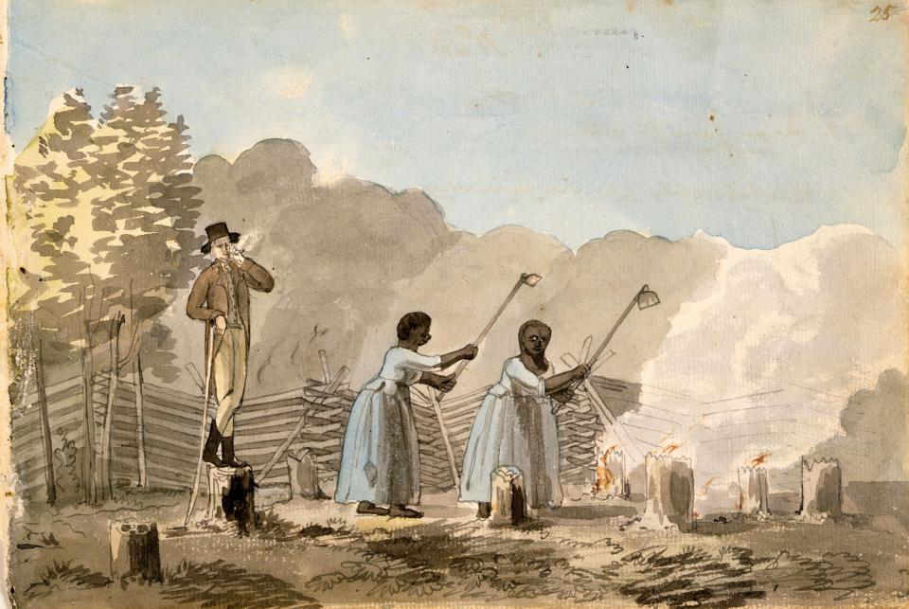An Overseer Doing his Duty, 1798, watercolor by Benjamin Henry Latrobe from his sketchbook. Latrobe observed this scene in Virginia of slave women clearing tree stumps from a field under the supervision of an overseer.
Laws in most colonies discouraged mix-raced relationships between black women and white men (and vice versa). Marriages between races were prohibited and the children born of Anglo-African relationships were always legally recognized as black. The children of enslaved women inherited the status of their mothers at birth. In the Dutch colony of New Netherland, female African slaves were imported to serve as laborers, but to also serve as wives and companions for the enslaved men as a measure to prevent miscegenation opens in new window.
You will explore the topic of women and slavery further in Slavery and the Making of America and in later modules.

Native American Women
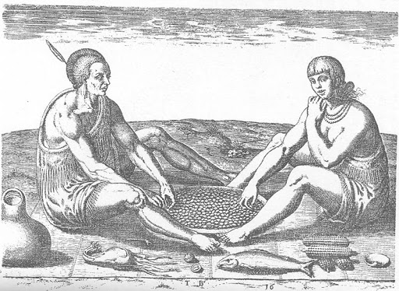Native man and woman (right) eating what she gathered
As we saw earlier, native women's roles were comparable to those of other women in colonial society. Native American women's lives revolved around their culture's ideas of marriage, motherhood, and domesticity. Premarital sex and divorce were more common among native women than colonial settlers as the religious prohibitions governing sexual relations and marriage in native culture were different from Christianity. Indian women usually gave birth alone in the forest without the aid of a midwife, returning to their villages after a day or two. Native women helped cultivate crops of corn, beans, and squash as well as gather plants, nuts, berries, and shellfish.
There are scattered references in some sources to female chiefs. It was common for powerful men to have more than one wife, but there are no records of a powerful woman having more than one husband. Elder women in many native communities, like the Iroquois, played significant roles in choosing the male leaders and removing them from power.
We've seen examples of native women marrying colonists, like Pocahontas of Virginia and Mary Musgrove of Georgia. The male colonists outnumbered the women in some colonial societies and it became common practice for white men to take native women as their wives. These couples usually lived in the western frontier regions of the colony and many of these men happened to be traders. Marriage to an Indian woman likely facilitated his trading business. The children of these marriages were known as "mixed-blood Indians" in native societies and were legally defined as white freemen and women by the colonial and later state governments. After the founding of the United States, Benjamin Hawkins, an Indian agent of the Federal government living with the Creeks, wrote about being approached by a native woman who wanted him to marry her daughter. He told her that his wife must be obedient to him and completely under his authority. In other words, she would not be influenced by her mother or family as was typical in native societies. Her response: "She would not consent that the woman and children should be under the direction of the father, and the negotiation ended there." Much of what we know about native women from this period comes from the observations of European observers like Benjamin Hawkins or Mary Rowlandson, who was captured by natives during King Philip's War and held for ransom for eleven weeks. She later recorded her experiences in a book. opens in new window Their reliability must always be considered when interpreting Native American history.
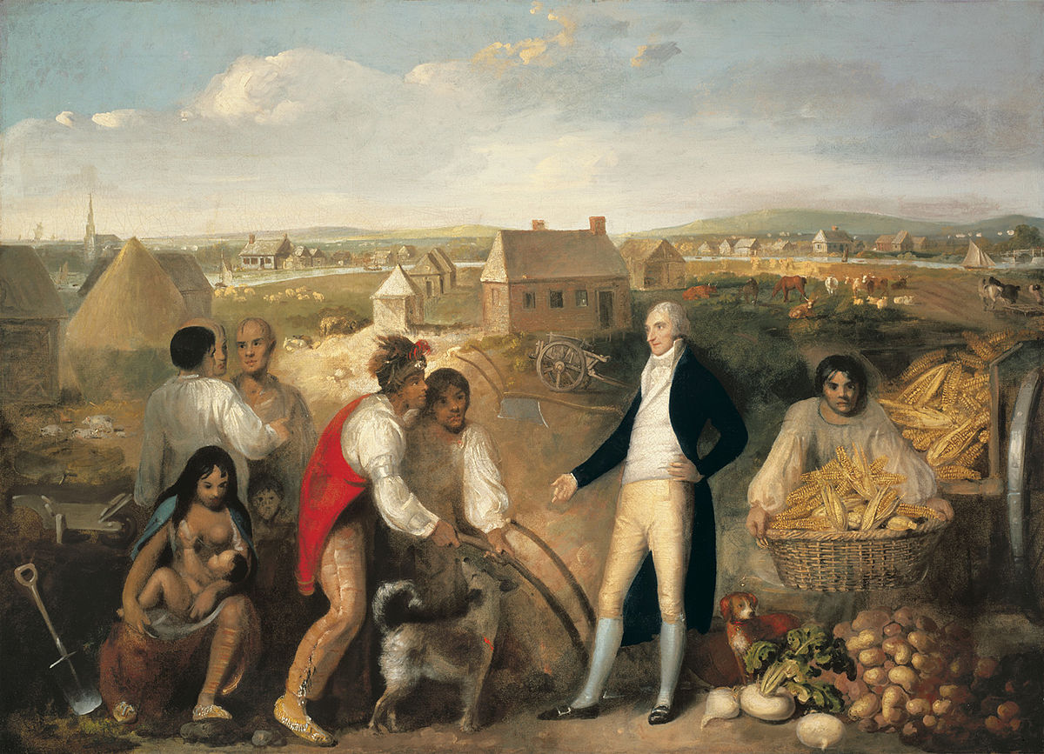Benjamin Hawkins and the Creek Indians (1805) by an unknown artist. In this painting, Hawkins is teaching Creek men how to use a plow on his plantation on the Flint River in central Georgia. The painting prominently features a Creek mother and child (bottom-left). Hawkins and other white observers of Native Americans described native women as lacking modesty, compared to white women, and would not think twice about nursing a baby in public. This once again brings up questions of reliability, as the observation may be accurate but the value judgment must be questioned.
We will be investigating American women's history throughout this course. In the last part of this module you'll be examining the factors in the eighteenth century that provided common experiences for the diverse array of colonies and colonists in British America.

